**Project 2**

**REQUIREMENT SPECIFICATION:**

**PROJECT NAME: ELECTRONIC MEDICAL RECORDS**

The database is a comprehensive system designed for managing medical records and appointments in an emergency section of a hospital or medical facility. The Patient table contains critical information about patients, such as their personal details, contact information, and emergency contact information. The Provider table contains essential details about healthcare providers, such as their specialties, phone number, and facility location. The Visit table tracks the patients' visit to the hospital or facility, including the provider involved, visit date and time, and facility location. The Clinical care table contains critical care information, including symptoms, diagnosis, prescriptions, and exam/procedure results. The Appointment table keeps track of patients' appointments, including appointment date and time, appointment type, and any appointment notes. The Exam room table stores information about the exam room, such as its name, location, and notes. The Bed table keeps track of the beds and their notes in the emergency section.

The Supplies table tracks the medical supplies, including their name, type, and quantity available. Lastly, the Billing table contains details about the billings associated with each visit, including the visit, patient, and provider involved, billing date and amount, and billing notes. Overall, this database provides a comprehensive solution for efficiently managing medical records and appointments in an emergency section of a hospital or medical facility.

**System Requirements:**

* The system must have the capability to store and manage patients' information, including their personal information, medical history, and billing details.
* The system must have the capability to store and manage healthcare providers' information, including their personal details, specialties, and contact information.
* The system must have the capability to store and manage visit information, including the patient and healthcare provider involved, the visit date and time, and the facility location.
* The system must have the capability to store and manage clinical care information, including the visit associated with it, symptoms, diagnoses, prescriptions, and exam/procedure results.
* The system must have the capability to store and manage appointment information, including the patient and healthcare provider involved, the appointment date and time, and the appointment type.
* The system must have the capability to store and manage ExamRoom information, including the exam room name, location, and notes.
* The system must have the capability to store and manage bed information, including the bed name and notes.
* The system must have the capability to store and manage supplies information, including the supply name, type, and quantity.
* The system must have the capability to store and manage billing information, including the visit, patient, and healthcare provider associated with it, the billing date and amount, and any billing notes.
* The system must have the capability to store user data.
* The system must have the capability to store and verify the audit trail information according to the roles.

**Functional Requirements:**

* The system should allow authorized users to create, read, update, and delete patient information.
* The system should allow authorized users to create, read, update, and delete provider information.
* The system should allow authorized users to create, read, update, and delete visit information.
* The system should allow authorized users to create, read, update, and delete clinical care information.
* The system should allow authorized users to create, read, update, and delete appointment information.
* The system should allow authorized users to create, read, update, and delete ExamRoom information.
* The system should allow authorized users to create, read, update, and delete bed information.
* The system should allow authorized users to create, read, update, and delete supplies information.
* The system should allow authorized users to create, read, update, and delete billing information.
* The system should allow authorized users to generate reports on patient visits, clinical care, appointments, and billing.
* The system should provide secure user authentication and authorization mechanisms to ensure data privacy and security.
* The system must have the capability to store user data.
* The system must have the capability to store and verify the audit trail information according to the roles.

**PATIENT TABLE**

The Patient table stores basic information about each patient, such as their name, date of birth, address, phone number, insurance information, and emergency contact information.

* pid: Patient ID
* firstname: First name of the patient
* lastname: Last name of the patient
* dob: Date of birth of the patient
* address: Address of the patient
* phone_number: Phone number of the patient
* insurance: Insurance of the patientemergencycontactname: Name of the emergency contact person of the patient
* emergencycontactphone: Phone number of the emergency contact person of the patient

**PROVIDER TABLE**

The Provider table stores information about healthcare providers, such as their name, specialty, phone number, and facility location.

* providerid: A unique identifier for each healthcare provider.
* firstname: The first name of the healthcare provider.
* lastname: The last name of the healthcare provider.
* specialty: The area of specialization for the healthcare provider.
* phno: The phone number of the healthcare provider.
* facilityloc: The location of the facility where the healthcare provider practices.

**VISIT TABLE**

The Visit table stores information about patient visits to healthcare providers, such as the visit date and time, facility location, and the patient and provider involved in the visit.

* vid: Visit ID
* visitdate: Date of visit
* visittime: Time of visit
* ccid: Clinical care ID
* symptoms: Symptoms of the patient
* dischargediagnosis: Diagnosis provided to the patient
* prescriptions: Prescriptions given to the patient
* examresults: Results of the examination conducted
* procedureresults: Results of the procedure conducted

**CLINICAL CARE:**

The Clinicalcare table stores information related to the care provided to patients during their visits, such as symptoms, diagnosis, prescriptions, exam results, and procedure results.

* Clinicalcare: A table in the healthcare database that stores information about the care provided to patients during their visits.
* ccid: A unique identifier for each record in the Clinicalcare table.
* vid: A foreign key that references the visit id associated with the care provided.
* Symptoms: A field that stores the symptoms reported by the patient during the visit.
* Diagnosis: A field that stores the diagnosis provided by the healthcare provider.
* Prescriptions: A field that stores the medications prescribed to the patient.
* Exam results: A field that stores the results of any exams or tests performed during the visit.
* Procedure results: A field that stores the results of any procedures performed during the visit.

**APPOINTMENT TABLE**

The Appointment table stores information about patient appointments with healthcare providers, such as the appointment date and time, appointment type, and appointment notes.

* aid: Appointment ID
* appointmentdate: Date of appointment
* appointmenttime: Time of appointment
* appointmenttype: Type of appointment
* appointmentnotes: Notes for the appointment

**EXAM TABLE**

The ExamRoom table stores information about exam rooms, such as the room name, facility location, and any notes related to the room.

* eid: Exam Room ID
* examroomname: Name of the exam room
* examroomnotes: Notes for the exam room

**BED TABLE**

The Bed table stores information about beds in the medical facility, such as the bed name and any notes related to the bed.

* bedid: Bed ID
* bedname: Name of the bed
* bednote: Notes for the bed

**SUPPLY TABLE**

The Supplies table stores information about medical supplies, such as the supply name, type, and quantity.

* supplyid: Supply ID
* supplyname: Name of the supply
* supplytype: Type of the supply
* supplyquantity: Quantity of the supply

**BILLING TABLE:**

Finally, the Billing table stores information about bills for medical services provided to patients, including the visit, patient, and provider associated with the bill, the billing date and amount, and any notes related to the bill.

* billingid: Billing ID
* billingdate: Date of billing
* billingamount: Amount of the billing
* billingnotes: Notes for the billing

**USER TABLE:**

The Users table stores information about the users of the system, such as the username, password, and user role.

• userid: User ID

• username: Username

• password: Encrypted password

• userrole: Role of the user in the system (e.g. admin, doctor, nurse)

**AUDIT TRAIL TABLE:**

The Audit Trail table stores information about every query or change made to the database, including the user and time of access.

• id: Audit trail ID

• userid: User ID who made the query or change

• datetime: Date and time of the query or change

• action: Description of the action performed (e.g. SELECT, INSERT, UPDATE, DELETE)

**Patient table:**

|  |  |  |
| --- | --- | --- |
| **Attribute** | **Data Type** | **Description** |
| pid (Primary Key) | INT | Unique identifier for a patient |
| firstname | VARCHAR | First name of the patient |
| lastname | VARCHAR | Last name of the patient |
| dob | DATE | Date of birth of the patient |
| address | VARCHAR | Address of the patient |
| phone_number | VARCHAR | Phone number of the patient |
| insurance | VARCHAR | Insurance information of the patient |
| emergencycontactname | VARCHAR | Name of the emergency contact for the patient |
| emergencycontactphone | VARCHAR | Phone number of the emergency contact for the patient |

**Provider table**:

|  |  |  |
| --- | --- | --- |
| **Attribute** | **Data Type** | **Description** |
| providerid (Primary Key) | INT | Unique identifier for a healthcare provider |
| firstname | VARCHAR | First name of the healthcare provider |
| lastname | VARCHAR | Last name of the healthcare provider |
| specialty | VARCHAR | Specialty of the healthcare provider |
| phno | VARCHAR | Phone number of the healthcare provider |
| facilityloc | VARCHAR | Facility location of the healthcare provider |

**Visit Table:**

|  |  |  |
| --- | --- | --- |
| **Attribute** | **Data Type** | **Description** |
| vid (Primary Key) | INT | Unique identifier for a visit |
| pid (Foreign Key) | INT | Patient identifier who had the visit (references Patient table) |
| providerid (Foreign Key) | INT | Healthcare provider identifier who provided the visit (references Provider table) |
| visitdate | DATE | Date of the visit |
| visittime | TIME | Time of the visit |
| facilityloc | VARCHAR | Location of the facility where the visit took place |

**Clinical care table:**

|  |  |  |
| --- | --- | --- |
| **Attribute** | **Data Type** | **Description** |
| ccid (Primary Key) | INT | Unique identifier for a clinical care record |
| vid (Foreign Key) | INT | Visit identifier for the clinical care record (references Visit table) |
| symptoms | TEXT | Symptoms observed during the visit |
| dischargediagnosis | TEXT | Diagnosis made by the healthcare provider at discharge |
| prescriptions | TEXT | Prescriptions given to the patient during the visit |
| examresults | TEXT | Results of any exams conducted during the visit |
| procedureresults | TEXT | Results of any procedures conducted during the visit |

**Appointment table:**

|  |  |  |
| --- | --- | --- |
| **Attribute** | **Data Type** | **Description** |
| aid (Primary Key) | INT | Unique identifier for an appointment |
| pid (Foreign Key) | INT | Patient identifier who has the appointment (references Patient table) |
| providerid (Foreign Key) | INT | Healthcare provider identifier who will be seeing the patient (references Provider table) |
| appointmentdate | DATE | Date of the appointment |
| appointmenttime | TIME | Time of the appointment |
| appointmenttype | VARCHAR | Type of appointment (e.g. follow-up, initial consultation) |
| appointmentnotes | TEXT | Additional notes related to the appointment |

**Supplies table:**

|  |  |  |
| --- | --- | --- |
| **Field Name** | **Data Type** | **Description** |
| supplyid | INT | Primary key for supplies table |
| supplyname | VARCHAR | Name of the supply |
| supplytype | VARCHAR | Type of supply |
| supplyquantity | INT | Quantity available |

**Billing table:**

|  |  |  |
| --- | --- | --- |
| **Field Name** | **Data Type** | **Description** |
| billingid | INT | Primary key for Billing table |
| vid | INT | Foreign key referencing Visit table |
| pid | INT | Foreign key referencing Patient table |
| providerid | INT | Foreign key referencing Provider table |
| billingdate | DATE | Date of the billing |
| billingamount | DECIMAL(10,2) | Amount billed |
| billingnotes | TEXT | Additional notes for the billing |

**ExamRoom table:**

|  |  |  |
| --- | --- | --- |
| **Field Name** | **Data Type** | **Description** |
| eid | INT | Primary key for ExamRoom table |
| examroomname | VARCHAR | Name of the exam room |
| facilityloc | VARCHAR | Location of the exam room |
| examroomnotes | TEXT | Additional notes for exam room |

**Bed Table:**

|  |  |  |
| --- | --- | --- |
| **Field Name** | **Data Type** | **Description** |
| bedid | INT | Primary key for Bed table |
| bedname | VARCHAR | Name of the bed |
| bednote | TEXT | Additional notes for the bed |

**Audit trail table:**

|  |  |  |
| --- | --- | --- |
| **Field Name** | **Data Type** | **Description** |
| audit_id | INT | Primary key for the AuditTrail table |
| userid | INT | ID of the user performing the action |
| datetime | DATETIME | Date and time of the action |
| action | VARCHAR | Description of the action performed |

**Users Table:**

|  |  |  |
| --- | --- | --- |
| **Field Name** | **Data Type** | **Description** |
| user_id | INT | Primary key for Users table |
| username | VARCHAR(50) | User's login username, must be unique |
| password | VARCHAR(255) | User's login password, stored hashed for security |

**UML DATA MODEL:**

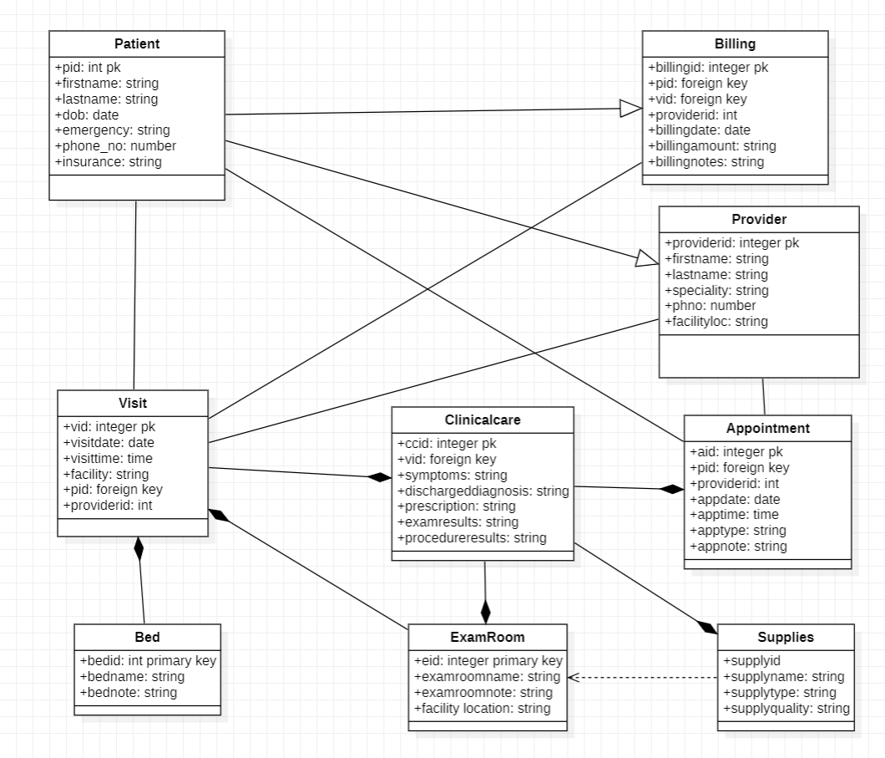

**ER MODEL:**

